Marwadi University
Faculty of Computer Applications
BCA 4E Python Mid-1 Exam
Enrollment No. : 92400527370
Name : EMMANUEL ONAH
Class : BCA 4 E
Date : 12/03/2026
Answer – 1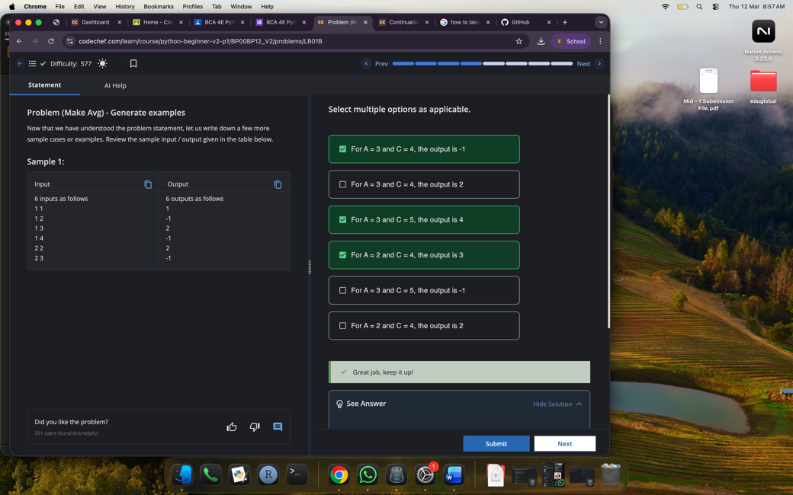
Answer – 2
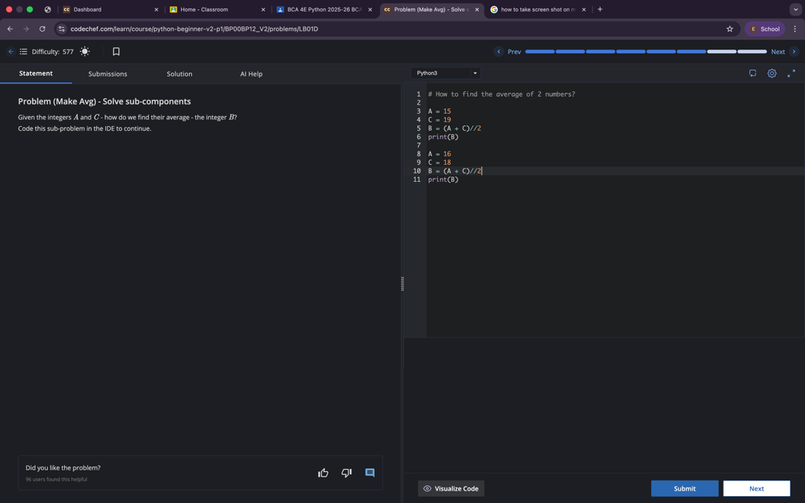
Answer – 3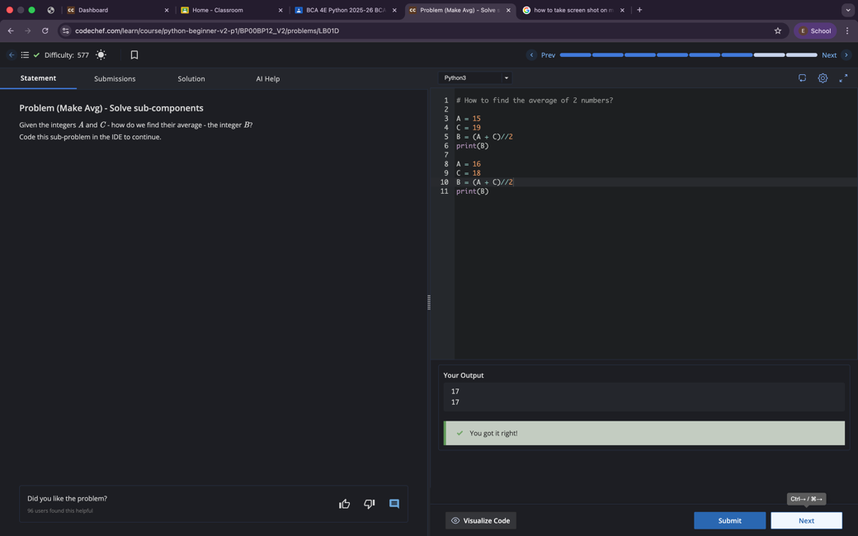
Answer – 4
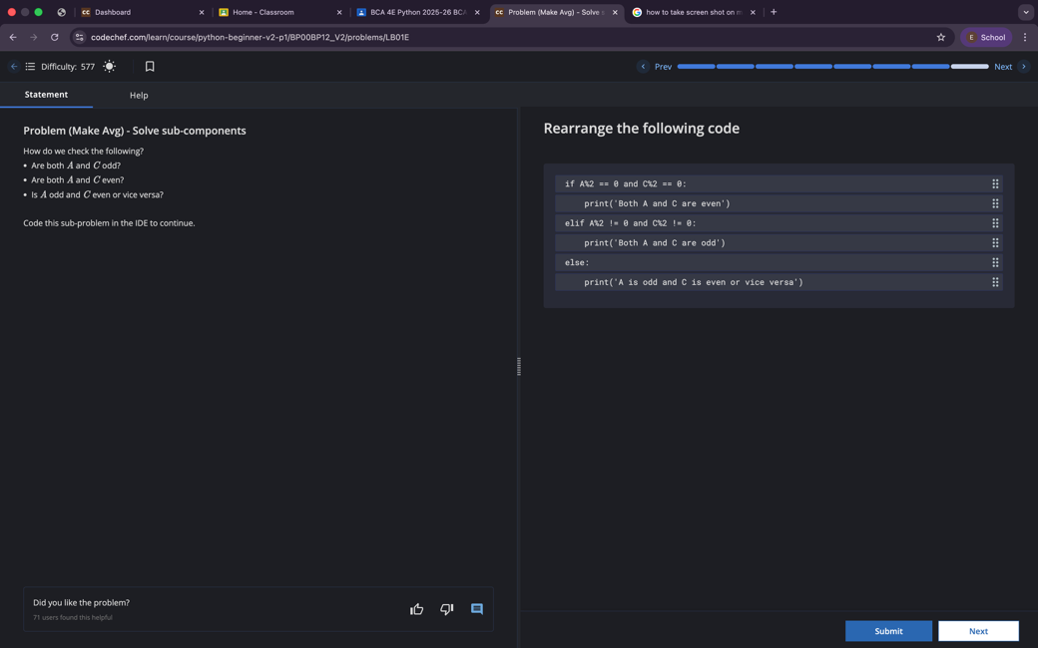
Answer - 5